VCE UNIT 4 ART

The Representation of the Female Body in Art

FEATURED ARTIST: Alessandro Botticelli

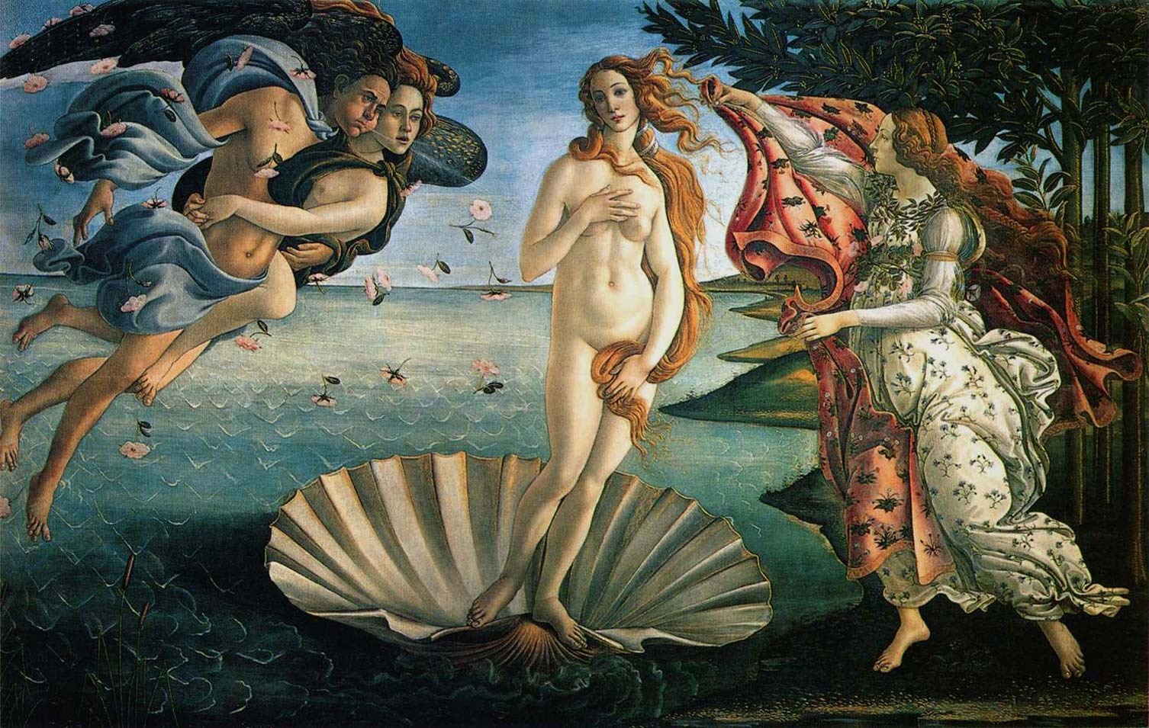

*The Birth of Venus*, 1485. Tempera on wood 203 x 314 cm

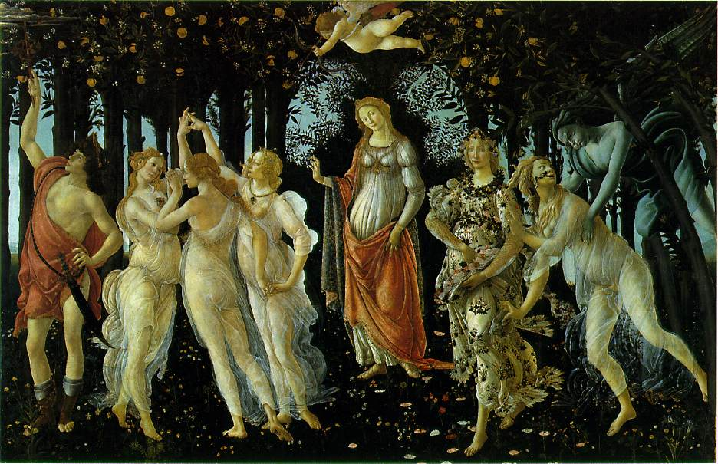

*La Primavera*, 1482 .Tempera on wood 203 x 314 cm

THINK, INVESTIGATE, CREATE

Your activity is to:

1. Carefully read the provided commentaries by Clark and Jones provided below.
2. Respond to the commentaries by analysing how they can be used in discussion about Botticelli’s ***The Birth of Venus***and ***La Primavera****.*  Pay particular attention to Jones’ statement about ‘*Clarke images the form as potential perfection’.*
3. Use the Formal and Cultural Frameworks to help with discussion in terms of evidence to the commentaries.
4. Do you think Botticelliobjectifies the female bodythrough ***The Birth of Venus***and ***La Primavera***? Explain why/why not using evidence from the paintings.
5. Provide evidence from Botticelli’s painting to support your opinion!!

COMMENTARIES

**‘*The Nude remains a landmark (albeit an increasingly controversial one) in the description of the female body as art form. Indeed, for Clark the female nude represents the triumph of art: the ultimate transformation of matter into form. In these terms the image of the female nude is a pure form, one that, rather than provoking action, encourages contemplation, even reverence. To make his point Clark differentiates between the celestial and the earthly Venus. The former represents a perfection of the female form, so abstracted from sexual pleasure that it can sanction the male gaze and turns the female body into a work of art. The earthly Venus, by contrast, is warmly sensual, its wanton form always on the brink of immodesty. As such it is taken to be a less deserving object. Clark's statement is a classic example of the ways in which art criticism has sought to regulate the female form’.***

Kenneth Clark's 1956

**‘*Clarke images the form as potential perfection’.***

Robert W. Jones