VCE UNIT 4 ART
The Representation of the Female Body in Art

FEATURED ARTIST: Édouard Manet

Olympia, 1863. Oil on canvas, 130.5cm x190cm
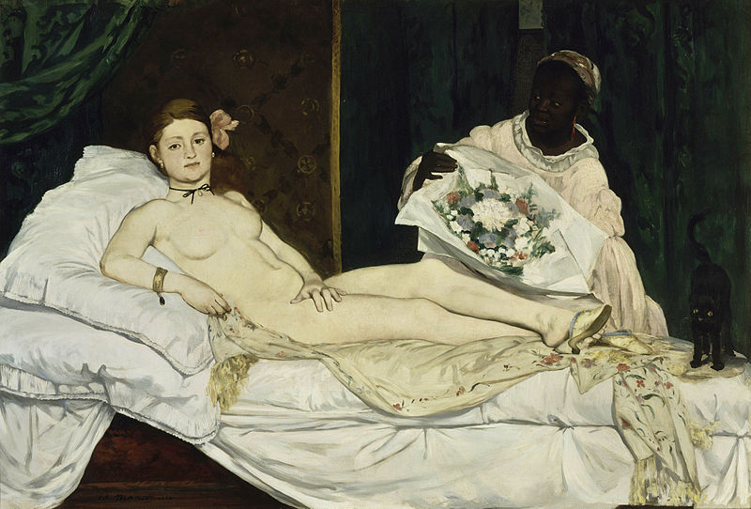

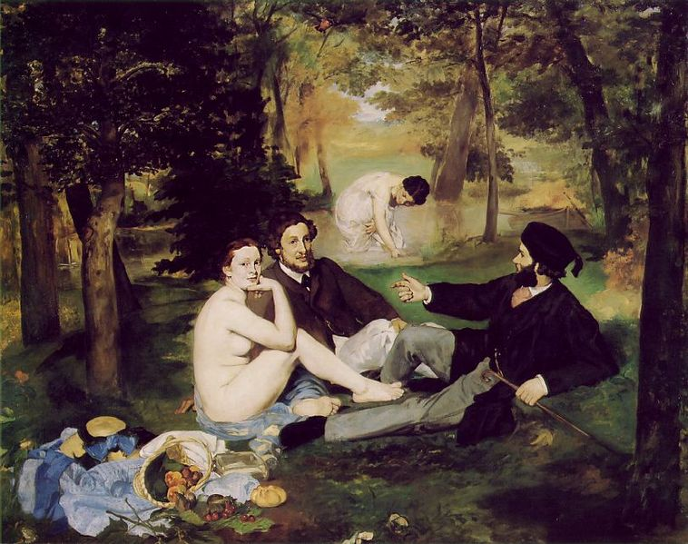

Luncheon on the Grass, 1862 – 1863. Oil on canvas, 208 cm x 265.5 cm

THINK, INVESTIGATE, CREATE

Your activity is to:

- Carefully read the provided commentaries by Berger and Nochlin provided below.
- Respond to the commentaries by analysing how they can be used in discussion about Édouard Manet’s Olympia and Luncheon on the Grass.
- Use the Formal framework and Cultural Frameworks to conduct an analysis on both works to help with discussion in terms of evidence to the commentaries.
- How does Manet’s works Olympia and Luncheon on the Grass objectify the female nude? In your response discuss the idea of commodity and explain by using evidence from the paintings.
- Is there evidence of Berger’s statement “...in European art from the Renaissance onwards women were depicted as being ‘aware of being seen by a [male] spectator” in Manet’s works Olympia and Luncheon on the Grass? Discuss.
- By means of this very famous quote by Berger 1972: “Men act and women appear. Men look at women. Women watch themselves being looked at”, discuss this commentary with reference to one of Manet’s works.
- Read the following statement by Linda Nochlin:
“The male image is one of power, possession and domination, the female is one of submission, passivity and availability” — Linda Nochlin, 1972
Do you agree or disagree with this statement? Why/Why not? Support your response with evidence from the four artworks.
- Make sure you provide evidence from Manet’s paintings to support your opinion!!

COMMENTARIES

‘Men act and women appear. Men look at women. Women watch themselves being looked at’.
— John Berger 1972

Berger argues that in European art from the Renaissance onwards women were depicted as being ‘aware of being seen by a [male] spectator’
— John Berger 1972

“The male image is one of power, possession and domination, the female is one of submission, passivity and availability”
— Linda Nochlin 1972

