VCE UNIT 4 ART
The Representation of the Female Body in Art

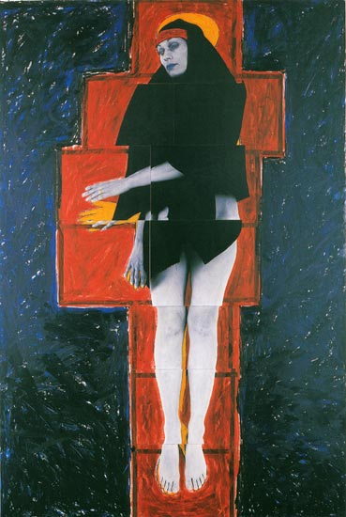FEATURED ARTIST: Julie Rrap

Persona and Shadow:Madonna, 1984
Cibachrome printpia, Manet. 1863

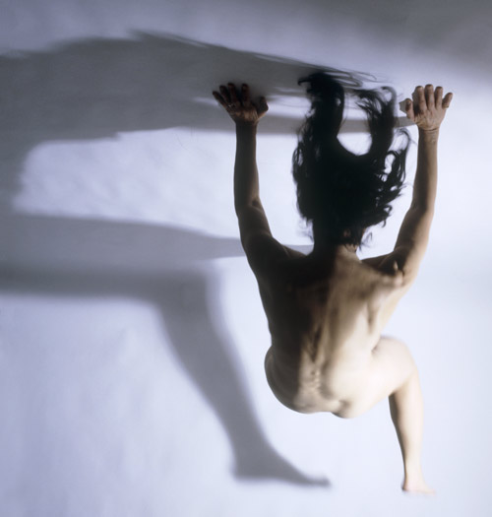

Yaw, 2004
From the series Soft Targets
Digital print 120 x 120 cm 1863

THINK, INVESTIGATE, CREATE

Your activity is to:

- Read through the Julie Rrap: Body Double Education Kit.
- Carefully read the provided commentaries provided below.
How does Rrap use nakedness to explore the relationship between artist subject and viewer? Do you agree with Exhibition curator Victoria Lynn that the strategy of ‘nakedness’ allows ‘the gaze (to be) returned to the audience’? These include her choice of: materials, camera position, lighting, clothing, nakedness, movement, non-movement, her treatment of point of view and her choice to make a work interactive or not.
- Consider the fragmentation of the body image in popular culture. How have postmodernism and feminism worked to differently interpret and reconfigure the body? Refer to examples to support your answer and commentaries
- How has the perception of images of female nudity changed over time or in various contexts? Discuss your different responses to these images in an art gallery, in magazines or on the internet. What informs your reactions? How do people of a different generation, for example your parents or teacher, respond?
- Make sure you provide evidence from Rrap’s works to support your opinion!!

COMMENTARIES

“Exhibition curator Victoria Lynn talks about ‘the gaze returned to the audience’ as an element in Rrap’s work. Rrap uses a variety of strategies to explore the relationship between the artist, subject and viewer…”

─ Reproduced from Julie Rrap: Body Double exhibition introductory wall tex , written by Victoria Lynn, 2007

“Rrap makes clear that she is the photographer, the author of the image, as well as the model, dressed and undressed, posing and not posing, performing for her own camera. She has said that she was ‘taking my clothes off and authoring myself doing that”.’

─ Julie Rrap in interview with Terence Maloon, ‘Interview with Terence Maloon’, Julie Rrap, Piper Press, 1998, p.117

